

Ismaeel Shahbaz (2233171)

Ma’am Samina Bloch

Computer Networks

**National College of Business Administration & Economics**

**Lab No. 1**

**Cisco Packet tracer**

Cisco Packet Tracer is a network simulation tool that simulates networks, including LAN, WAN, and WLAN and devices such as routers, switches, servers, and endpoints. It also creates network topologies, configures network devices, and troubleshoots network issues.

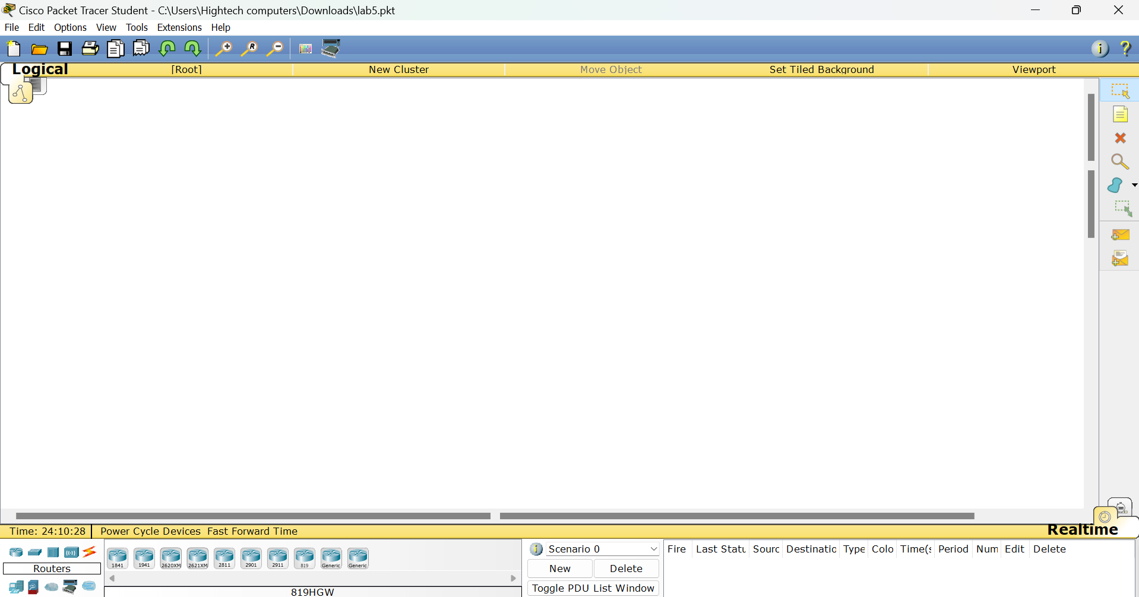

**Steps to Download Cisco Packet Tracer**

To download Cisco Packet Tracer, follow these steps:

* Go to the Cisco Networking Academy website: Visit the Cisco Networking Academy website at https://www.netacad.com/.
* Sign in or create an account: If you already have an account, sign in. If not, you may need to create one.
* Enroll in a course or locate Packet Tracer: Once you're signed in, navigate to the course materials or search for Packet Tracer in the resources section.
* Download Packet Tracer: Once you've located Packet Tracer, there should be an option to download it. Click on the download link.
* Choose the appropriate version: Make sure to select the version of Packet Tracer that is compatible with your operating system.
* Follow the installation instructions: After the download is complete, run the installer and follow the on-screen instructions to install Packet Tracer on your computer.
* Activate Packet Tracer (if required): Depending on your situation, you may need to activate Packet Tracer using your Cisco Networking Academy credentials. Follow any prompts for activation.
* Launch Packet Tracer: Once installed, you should be able to launch Packet Tracer from your desktop or start menu.
* That's it! You should now have Cisco Packet Tracer installed on your computer and ready to use for networking simulations and practice.

**Basic Functions of Cisco Packet tracer**

* **Network Device Selection:** Packet Tracer provides a wide range of network devices that users can select and add to their network topology. These devices include routers, switches, hubs, wireless devices, PCs, servers, and more.
* **Topology Design:** Users can design network topologies by dragging and dropping devices onto the Packet Tracer workspace. They can connect devices using various types of cables and connectors.
* **Device Configuration:** Packet Tracer allows users to configure the settings of network devices. This includes assigning IP addresses, setting up routing protocols, configuring VLANs, implementing security features, and more.
* **Packet-Level Simulation:** Packet Tracer simulates the movement of data packets through the network topology. Users can observe how packets are routed, switched, and transmitted between devices. Packet Tracer provides detailed information about packet headers, payloads, and transmission delays.
* **Network Protocols Support:** Packet Tracer supports a wide range of network protocols, including TCP/IP, UDP, ICMP, OSPF, EIGRP, RIP, DHCP, DNS, and more. Users can configure and test these protocols within the simulated environment.
* **Wireless Network Simulation:** Packet Tracer includes support for simulating wireless networks. Users can add wireless devices such as access points and clients, configure wireless settings, and simulate wireless communication.
* **Visualization Tools:** Packet Tracer provides visualization tools to help users understand and analyze network behavior. Users can view network topology diagrams, traffic flows, device status indicators, and network performance metrics.
* **Simulation Control:** Packet Tracer allows users to control the simulation environment. They can start, stop, pause, and resume simulations at any time. Users can also adjust simulation parameters such as time, speed, and packet loss.
* **Activity Wizard:** Packet Tracer includes an Activity Wizard that guides users through step-by-step network configuration tasks. This feature is especially useful for educational purposes, as it provides structured learning activities and tutorials.
* **Collaboration Features:** Packet Tracer includes collaboration features that enable users to work on network projects collaboratively. Users can share Packet Tracer files with others, collaborate in real-time, and exchange feedback and ideas.

**Lab No. 2**

**Project Title:** **Linking two hosts that are part of the same network together**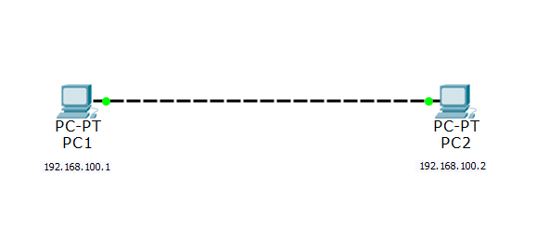

**Description:**

* In this project, you'll use Cisco Packet Tracer to simulate a basic network setup where two PCs (PC1 and PC2) are interconnected and communicate with each other.

**Steps:**

**Network Setup:**

* Open Cisco Packet Tracer and create a new project.
* Drag two PC devices (PC1 and PC2) from the device panel onto the workspace.
* Connect the PCs using an Ethernet cable. You can do this by selecting the appropriate cable type and clicking from one PC's Ethernet port to the other PC's Ethernet port.

**Assigning IP Addresses:**

* Select PC1 and go to its desktop view.
* Configure the IP address for PC1. Right-click on the desktop, select "IP Configuration," and enter the desired IP address, subnet mask, and default gateway.
* Repeat the same process for PC2, assigning it a different IP address within the same subnet.
* Testing Connectivity:
* Go back to the network view.
* Power on both PCs by clicking on the power button.
* Open the command prompt or terminal window on PC1.
* Ping PC2's IP address from PC1's command prompt to verify connectivity. Use the ping command followed by PC2's IP address.

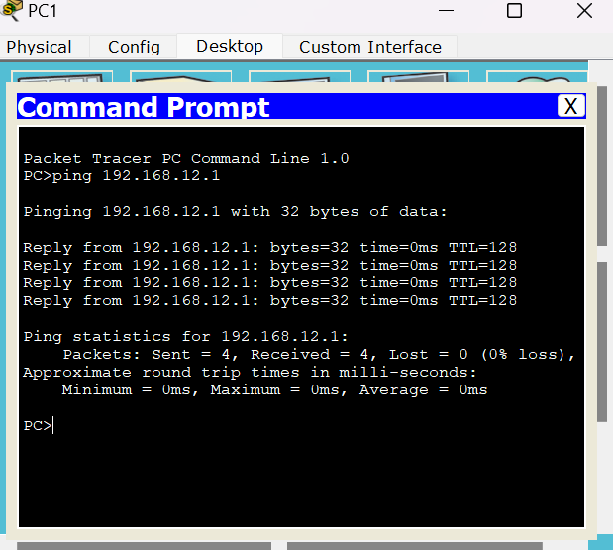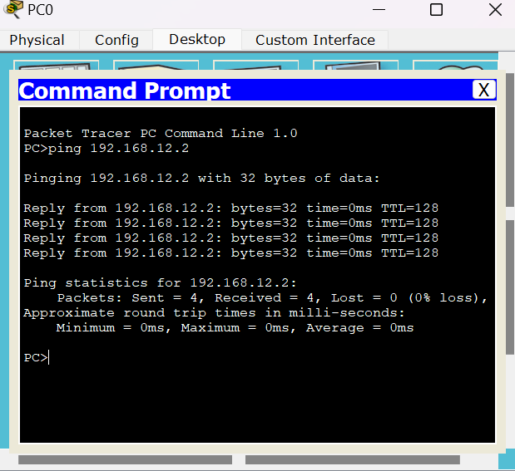

**Sending Messages:**

* With connectivity confirmed, you can now send a message from PC1 to PC2.
* Open a messaging application or terminal window on PC1.
* Compose a message addressed to PC2.
* Send the message and verify that it is received on PC2.

**Conclusion:**

By completing this project, you have successfully interconnected two PCs using Cisco Packet Tracer, assigned them IP addresses, and demonstrated the ability to send messages between them over the simulated network. This project serves as a fundamental exercise in network configuration and communication using Packet Tracer, providing hands-on experience in setting up a simple network environment.

**Lab No. 3**

**Project Title:** Simple LAN Create

**Description:**

In this project, you'll use Cisco Packet Tracer to simulate a basic network setup where three PCs (PC1, PC2, and PC3) are interconnected via a hub and communicate with each other.

**Steps:**

**Network Setup:**

* Open Cisco Packet Tracer and create a new project.
* Drag three PC devices (PC1, PC2, and PC3) from the device panel onto the workspace.
* Add a hub device to the workspace. You can find the hub device in the "Connectivity" section of the device panel.

**Assigning IP Addresses:**

* Select each PC (PC1, PC2, and PC3) and go to their desktop views.
* Configure the IP addresses for each PC. Right-click on the desktop, select "IP Configuration," and enter the desired IP address, subnet mask, and default gateway for each PC. Make sure each PC has a unique IP address within the same subnet.

**Connecting PCs to the Hub:**

* Use Ethernet cables to connect each PC to an available port on the hub. Click on the appropriate Ethernet port on each PC, then click on an available port on the hub to establish the connection.

**Sending Messages:**

With connectivity confirmed, you can now send messages between PCs.

Open a messaging application or terminal window on any PC.

Compose a message addressed to another PC.

Send the message and verify that it is received on the intended PC.

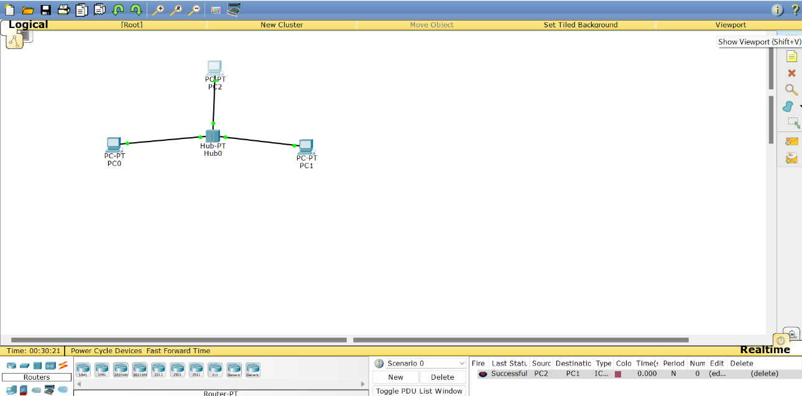

**Conclusion:**

By completing this project, you have successfully interconnected three PCs using a hub in Cisco Packet Tracer, assigned them IP addresses, and demonstrated the ability to send messages between them over the simulated network.

This project serves as an introductory exercise in network configuration and communication using Packet Tracer, providing hands-on experience in setting up a basic network topology with multiple nodes and communication between them.

**Lab No. 4**

**Project title:**

**Objective:**

The objective of this manual is to guide users through the process of setting up a basic network configuration in Cisco Packet Tracer. This configuration includes connecting a PC to a switch and configuring access control for the PC.

**Requirements:**

To follow this manual, you will need access to the Cisco Packet Tracer software. Ensure that you have a PC device and a Switch device available in Packet Tracer.

**Step-by-Step Instructions:**

**Connect PC and Switch:**

Begin by launching Cisco Packet Tracer and creating a new network project. Drag a PC device and a Switch device from the device panel onto the workspace. Establish a connection between the PC and the switch using a console cable. This cable physically connects the console port of the PC to an available port on the switch.

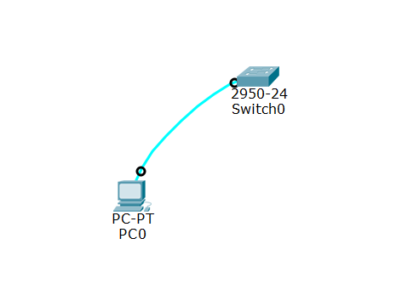

**Configure PC Hostname:**

Access the terminal interface of the PC by selecting it on the workspace. In the terminal, set a hostname for the PC using a command such as "hostname [hostname]." Replace "[hostname]" with the desired name for the PC. This hostname will help identify the PC on the network.

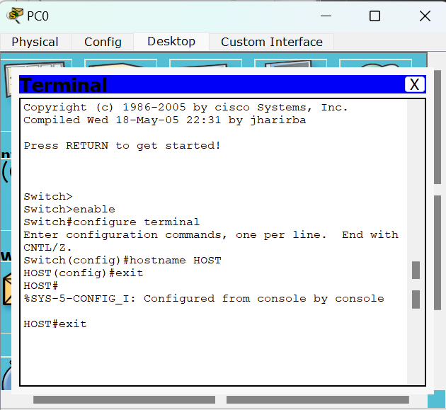

**Enable Privileged EXEC Mode:**

Enter privileged EXEC mode on the PC. This mode grants access to privileged commands that can modify the device's configuration and settings. This is typically done using the "enable" command in the terminal interface.

**Configure Global Configuration Mode:**

Access global configuration mode to make changes to the device's configuration. This mode allows you to configure settings that apply to the entire device. Use the "configure terminal" command to enter global configuration mode.

**Set Enable Password:**

Set an enable password to restrict access to privileged EXEC mode. This password will be required to enter privileged mode using the "enable" command. Choose a strong password and use the "enable password [password]" command to set it.



**Set Enable Secret Password:**

For enhanced security, set an enable secret password in addition to the enable password. The enable secret password is encrypted and provides a higher level of security compared to the enable password. Use the "enable secret [password]" command to set the enable secret password.

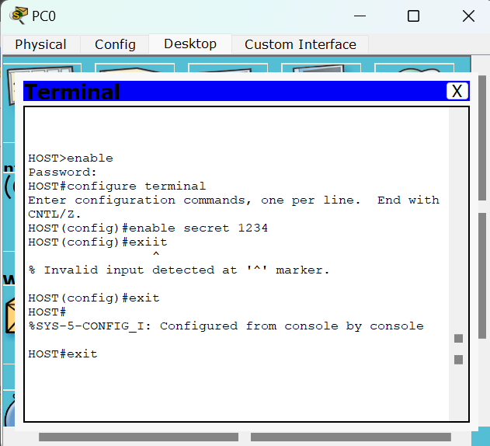

**Configure Console Line:**

Configure the console line to control access to the device's console port. This involves setting a password for console access and specifying other parameters such as login settings. Use commands like "line console 0" and "password [password]" to configure the console line.

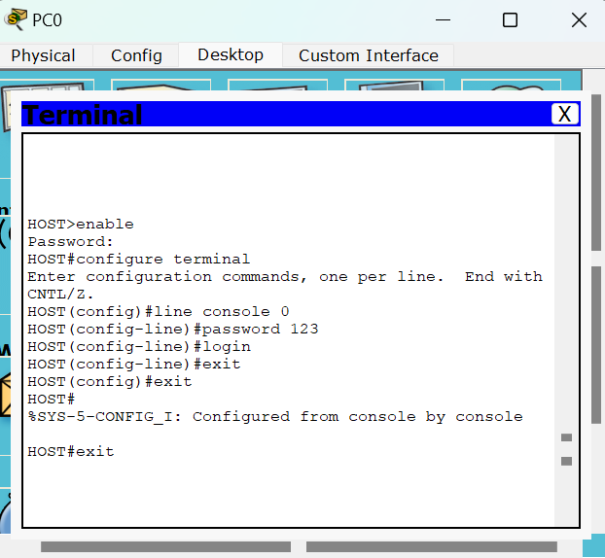

**Configure Virtual Terminal (VTY) Lines:**

Configure virtual terminal (VTY) lines to control access to the device via Telnet or SSH. Similar to the console line, set a password for remote access and specify login settings. Use commands like "line vty 0 15" and "password [password]" to configure VTY lines.

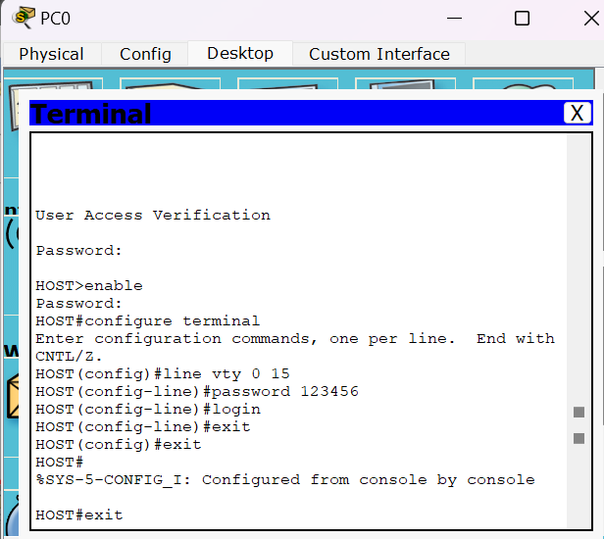

**Exit Configuration Mode:**

Once all configurations are complete, exit global configuration mode to return to privileged EXEC mode. Use the "exit" command to exit from global configuration mode.

**Save Configuration (Optional):**

After completing the configuration, it is recommended to save the changes to the device's configuration file. This ensures that the configuration persists across device reboots. Use the "copy running-config startup-config" command to save the configuration.

**Conclusion:**

By following these step-by-step instructions, users can successfully configure a basic network setup in Cisco Packet Tracer. The configured PC will have access control mechanisms in place, ensuring secure access to the device's privileged mode and console/remote access.

**Lab No. 5**

**Project Title: Basic Network Setup with PC and Router**

**Description:**

* In this project, you'll create a basic network setup using Cisco Packet Tracer, connecting a PC to a router and configuring the router for access control.

**Steps:**

**Network Setup:**

* Begin by launching Cisco Packet Tracer and creating a new project.
* Drag a PC device and a Router device from the device panel onto the workspace.
* Connect the PC to the router using an Ethernet cable. Click on the Ethernet interface of the PC and then click on one of the router's Ethernet interfaces to establish the connection.

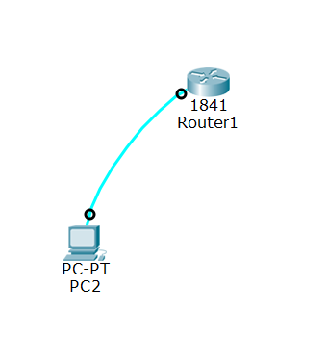

**Configure Router:**

* Access the terminal interface of the PC by selecting it on the workspace.
* Enter privileged EXEC mode on the PC by typing the enable command.
* Access the command line interface (CLI) of the router by typing the console command. This allows you to configure the router directly from the PC's terminal.

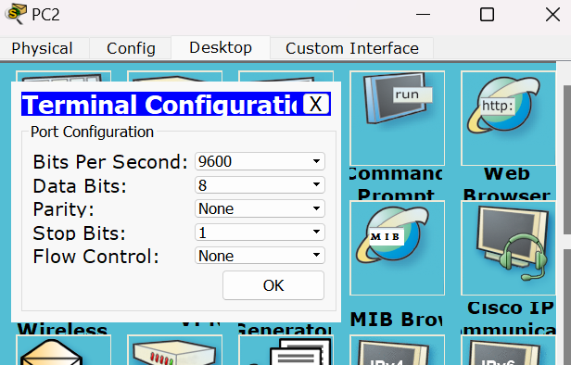

**Set Enable Password:**

* Once in the router's CLI, configure an enable password to control access to privileged EXEC mode. Use the enable password [password] command, replacing [password] with the desired password.

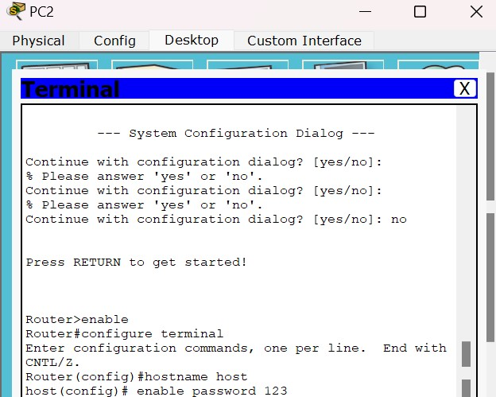

**Set Enable Secret Password:**

* For additional security, set an enable secret password. This password is encrypted and provides a higher level of security compared to the enable password. Use the enable secret [password] command to set it.

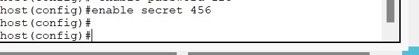

**Configure Virtual Terminal (VTY) Lines:**

* Configure virtual terminal (VTY) lines to control access to the device via Telnet or SSH. Similar to the console line, set a password for remote access and specify login settings. Use commands like "line vty 0 4" and "password [password]" to configure VTY lines.

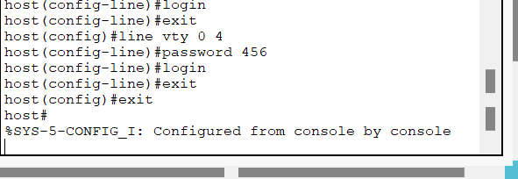

**Configure Additional Settings (Optional):**

* Depending on your project requirements, you can configure additional settings on the router such as interface IP addresses, routing protocols, DHCP, NAT, etc. These configurations will depend on the specific functionality you want to implement in your network.

**Save Configuration (Optional):**

* After completing the router configuration, it's a good practice to save the configuration to non-volatile memory to ensure it persists across reboots. Use the write memory or copy running-config startup-config command to save the configuration.

**Conclusion:**

By completing this project, you have successfully set up a basic network configuration in Cisco Packet Tracer, connecting a PC to a router and configuring access control on the router. This project serves as an introductory exercise in network configuration and lays the foundation for more advanced networking projects.

**Lab No, 6**

**Project Title:**

In project, I configured a DHCP server to assign IP addresses to three PCs connected to a switch. Here’s a detailed description of how to configure and implement a DHCP server in this setup:

**Network Topology**

1. **Devices Used**:
   * **Three PCs**
   * **One Switch**
   * **One DHCP Server (Server_PT)**
2. **Connections**:
   * PCs are connected to the switch using **Copper Straight-Through** cables.
   * 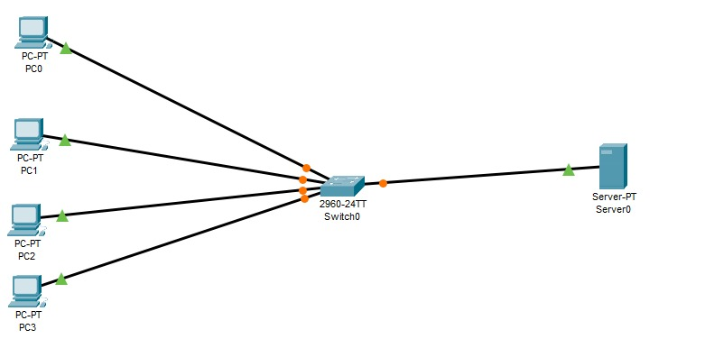The switch is connected to the DHCP server using a **Copper Straight-Through** cable.

**Step-by-Step Configuration:**

**Step 1: Set Up the Network Topology**

1. **Open Cisco Packet Tracer** and create a new project.
2. **Add the Devices**:
   * Drag and drop three PCs onto the workspace.
   * Add a switch (e.g., Cisco 2960).
   * Add a DHCP server (Server_PT).
3. **Connect the Devices**:
   * Use **Copper Straight-Through** cables to connect each PC to the switch.
   * Use another **Copper Straight-Through** cable to connect the switch to the DHCP server.

**Step 2: Configure the DHCP Server**

1. **Select the DHCP Server (Server_PT)** and go to the **Config** tab.
2. **Configure the Server’s IP Address**:
   * Go to **Global Settings** and set the server’s IP address (e.g., 192.168.1.1).
3. **Set Up the DHCP Service**:
   * Go to the **DHCP** tab.
   * Turn on the **DHCP Service**.
   * **Add a DHCP Pool**:
     + **Pool Name**: e.g., **Pool1**
     + **Default Gateway**: 192.168.1.1
     + **DNS Server**: (optional, e.g., 8.8.8.8)
     + **Starting IP Address**: e.g., 192.168.1.2
     + **Subnet Mask**: 255.255.255.0
     + **Max Users**: Set the number of users (e.g., 50).

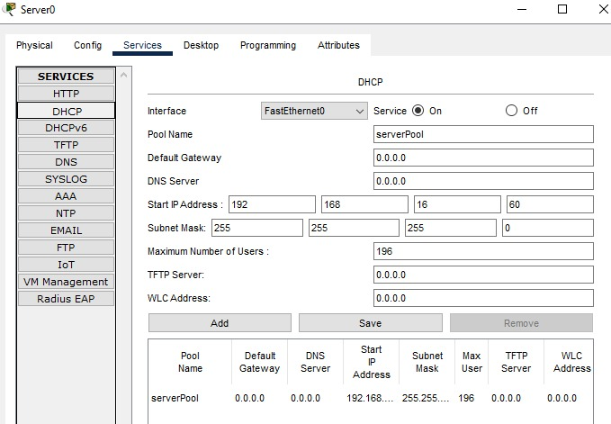

**Step 3: Configure the PCs to Obtain IP Addresses Automatically**

1. **Select each PC** and go to the **Desktop** tab.
2. Open the **IP Configuration** window.
3. 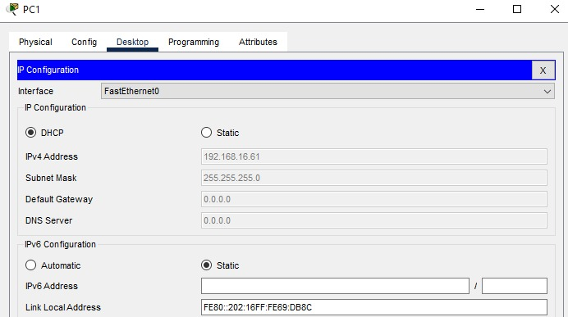**Set IP Configuration** to **DHCP**.

**Step 4: Verify the DHCP Configuration**

1. **Check the IP Address on Each PC**:
   * Open the **Command Prompt** on each PC.
   * Type **ipconfig** to see the IP address assigned by the DHCP server.
2. **Verify DHCP Leases on the DHCP Server**:
   * On the DHCP server, check the **DHCP** tab to see the list of IP addresses assigned to the PCs.

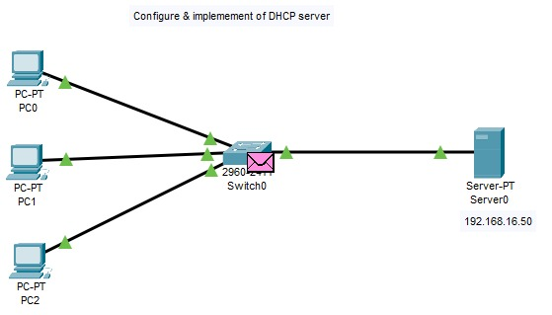

**Summary**

By configuring a DHCP server in Cisco Packet Tracer and connecting it to a switch with three PCs, you have automated the assignment of IP addresses to each PC. This setup ensures efficient IP address management and reduces the need for manual IP configuration on each device. The DHCP server dynamically provides IP addresses, gateway information, and optionally DNS server information to all connected PCs, streamlining network management.

**Lab No. 7**

Implementing static routing in Cisco Packet Tracer involves configuring routers with static routes to direct traffic to specific networks. Here’s a step-by-step guide to set up static routing between two networks using two routers:

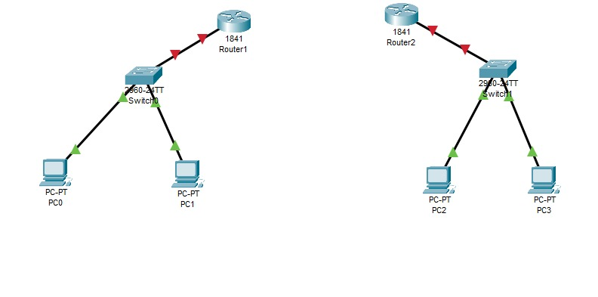**Network Topology**

Assume we have two networks:

Network 1: 192.168.1.0

Network 2: 192.168.2.0

**And two routers:**

Router 1 (R1)

Router 2 (R2)

**Step-by-Step Configuration**

Set Up the Network Topology in Packet Tracer:

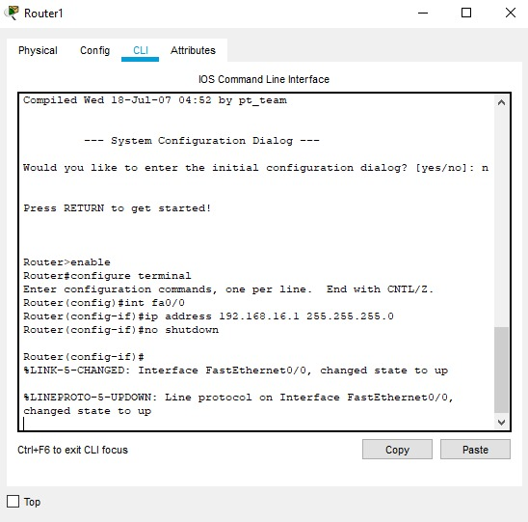

Place two routers (R1 and R2) on the workspace.

Connect the routers using a serial cable (e.g., Serial0/0/0 on both routers).

Connect PCs to each router using Ethernet cables (e.g., FastEthernet0/0).

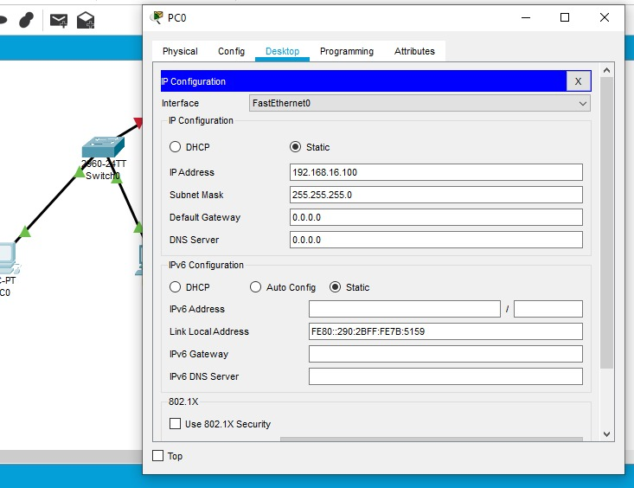**Configure IP Addresses:**

Assign IP addresses to the router interfaces and the PCs.

Router 1 (R1) Configuration:

Serial0/0/0 (to R2): 10.0.0.1/30

FastEthernet0/0 (to PC1): 192.168.1.1/24

Router 2 (R2) Configuration:

Serial0/0/0 (to R1): 10.0.0.2/30

FastEthernet0/0 (to PC2): 192.168.2.1/24

Configuration Commands for Router 1:

bash

Router1> enable

Router1# configure terminal

Router1(config)# interface serial0/0/0

Router1(config-if)# ip address 10.0.0.1 255.255.255.252

Router1(config-if)# no shutdown

Router1(config-if)# exit

Router1(config)# interface fastethernet0/0

Router1(config-if)# ip address 192.168.1.1 255.255.255.0

Router1(config-if)# no shutdown

Router1(config-if)# exit

Router1(config)# exit

**Configuration Commands for Router 2:**

bash

Router2> enable

Router2# configure terminal

Router2(config)# interface serial0/0/0

Router2(config-if)# ip address 10.0.0.2 255.255.255.252

Router2(config-if)# no shutdown

Router2(config-if)# exit

Router2(config)# interface fastethernet0/0

Router2(config-if)# ip address 192.168.2.1 255.255.255.0

Router2(config-if)# no shutdown

Router2(config-if)# exit

Router2(config)# exit

Configure Static Routing:

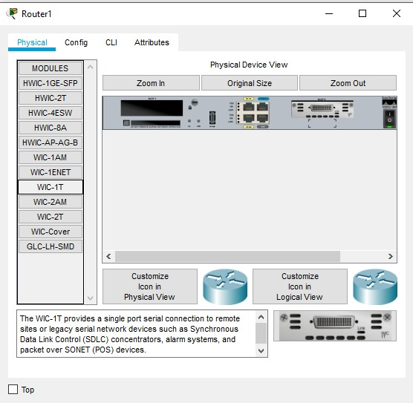Add static routes on both routers to direct traffic to the correct networks.

**Configuration Commands for Router 1:**

bash

Copy code

Router1> enable

Router1# configure terminal

Router1(config)# ip route 192.168.2.0 255.255.255.0 10.0.0.2

Router1(config)# exit

**Configuration Commands for Router 2:**

bash

Copy code

Router2> enable

Router2# configure terminal

Router2(config)# ip route 192.168.1.0 255.255.255.0 10.0.0.1

Router2(config)# exit

Verify the Configuration:

Use ping and traceroute commands to ensure connectivity between the networks.

Verify from Router 1:

bash

Copy code

Router1# ping 192.168.2.1

**Verify from Router 2:**

bash

Copy code

Router2# ping 192.168.1.1

Save the Configuration:

Save the running configuration to the startup configuration to ensure it persists after a reboot.

**Save Configuration Commands:**

bash

Copy code

Router1# write memory

Router2# write memory

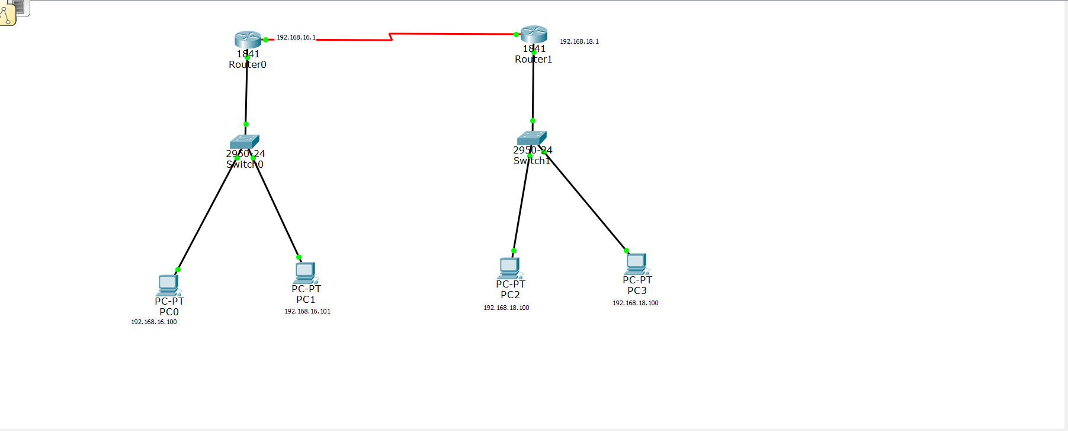

By following these steps, you should have successfully implemented static routing between the two networks in Cisco Packet Tracer. This setup ensures that Router 1 knows how to reach Network 2 and Router 2 knows how to reach Network 1.

**Lab No. 8**

**Title: Interconnecting Two Networks Using Cisco Packet Tracer**

**Introduction:** This project serves as a practical demonstration of network interconnectivity using Cisco Packet Tracer. By employing fundamental networking principles, we established communication between two distinct networks. The setup involved configuring devices, addressing schemes, and routing protocols to facilitate seamless data exchange across network boundaries.

**Methodology:**

1. **Network Design:**
   * We structured two independent networks, each comprising PCs, switches, and routers.
   * The topology ensured a clear delineation of network segments, promoting efficient traffic management.

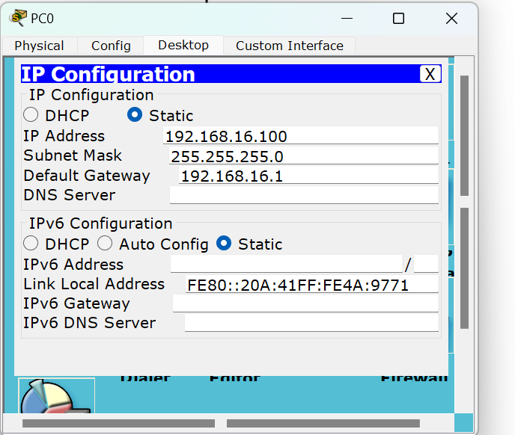

1. **Device Configuration:**
   * IP addressing was meticulously assigned to devices within each network, adhering to a hierarchical scheme for scalability and organization.
   * Routers were configured with IP addresses corresponding to their interfaces, enabling intra-network communication.

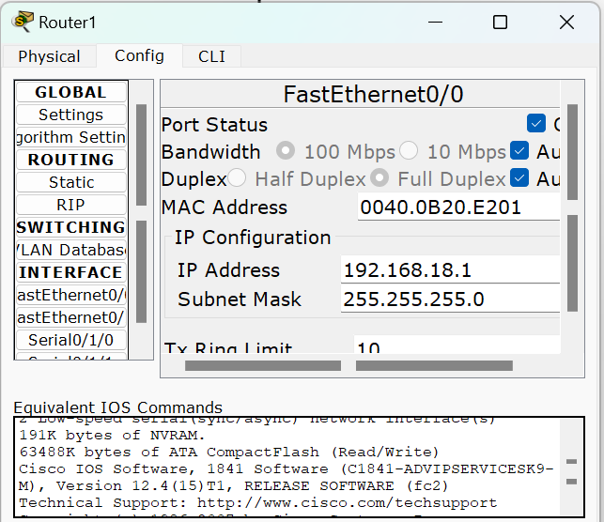

1. **Interconnecting Routers:**
   * Serial DTE connections were established between routers, establishing physical links for inter-network communication.
   * These connections were configured to ensure reliability and optimal data transmission between network boundaries.

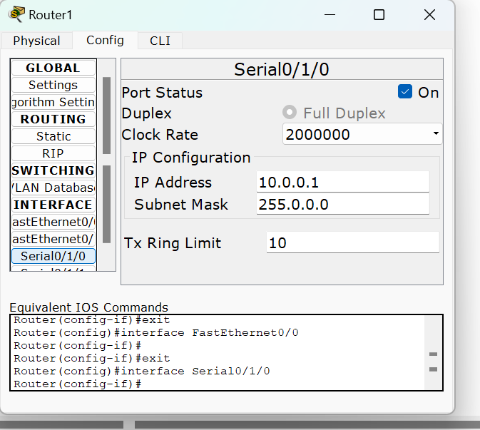

1. **Routing Setup:**
   * Utilizing the Cisco IOS Command Line Interface (CLI), default routes were configured on routers.
   * 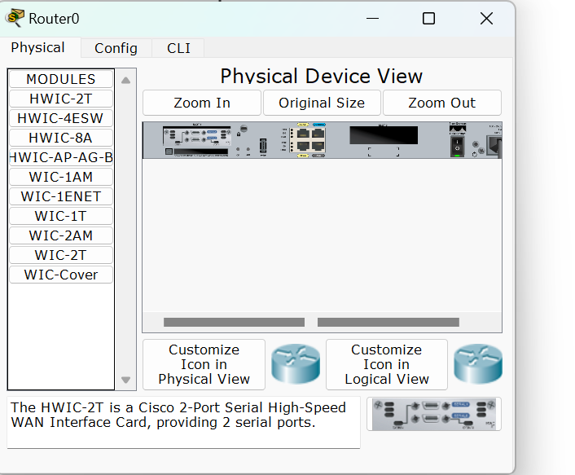The default route specification (**0.0.0.0 0.0.0.0 <next-hop>**) allowed routers to forward packets with unknown destinations to the specified next-hop address, facilitating inter-network communication.

**Results:** Through meticulous configuration and implementation:

* Devices within each network could communicate seamlessly, fostering internal collaboration and data sharing.
* Inter-network communication was established via routers, enabling data exchange between PCs in distinct network domains.



**Conclusion:** This project underscores the significance of network interconnectivity in modern infrastructures. By leveraging Cisco Packet Tracer's simulation environment, we successfully orchestrated the integration of disparate networks. The configured setup highlights the essential role of routers in bridging network segments, thereby enabling cohesive communication across organizational boundaries.